

**B2W CHALLENGE**

Price Analysis

# Problem

In the highly competitive Market, constantly the companies have to find ways to adjust or optimize the relationship between Price and Demand.

# Goal

The main objective is to create a model to predict the quantity sold for each product given a prescribed price. Along with the statistical model, we need metrics, relationships and descriptions of these data in order to understand the sales behavior.

# Methodology

To complete this challenge, I performed the following steps, according some steps to the CRISP-DM methodology:

- Data Understanding

- Data Preparation

- Modeling

- Evaluation

# Data Understanding

In this step, several methods were applied to find out more about the loaded data.

Below I’ll show some descriptive statistics about the products.

## 4.1. P1

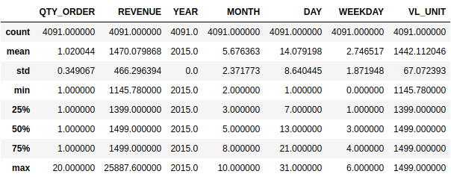

Firstly, it's possible to observe in the table above that the QTY_ORDER column has a minimum value of 1 and a maximum of 20 quantities sold, with mean approximately 1. In the REVENUE column